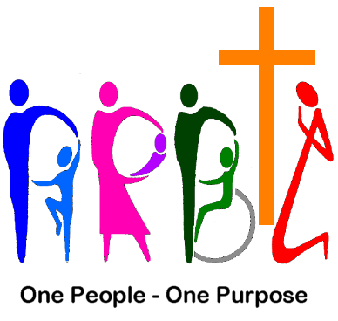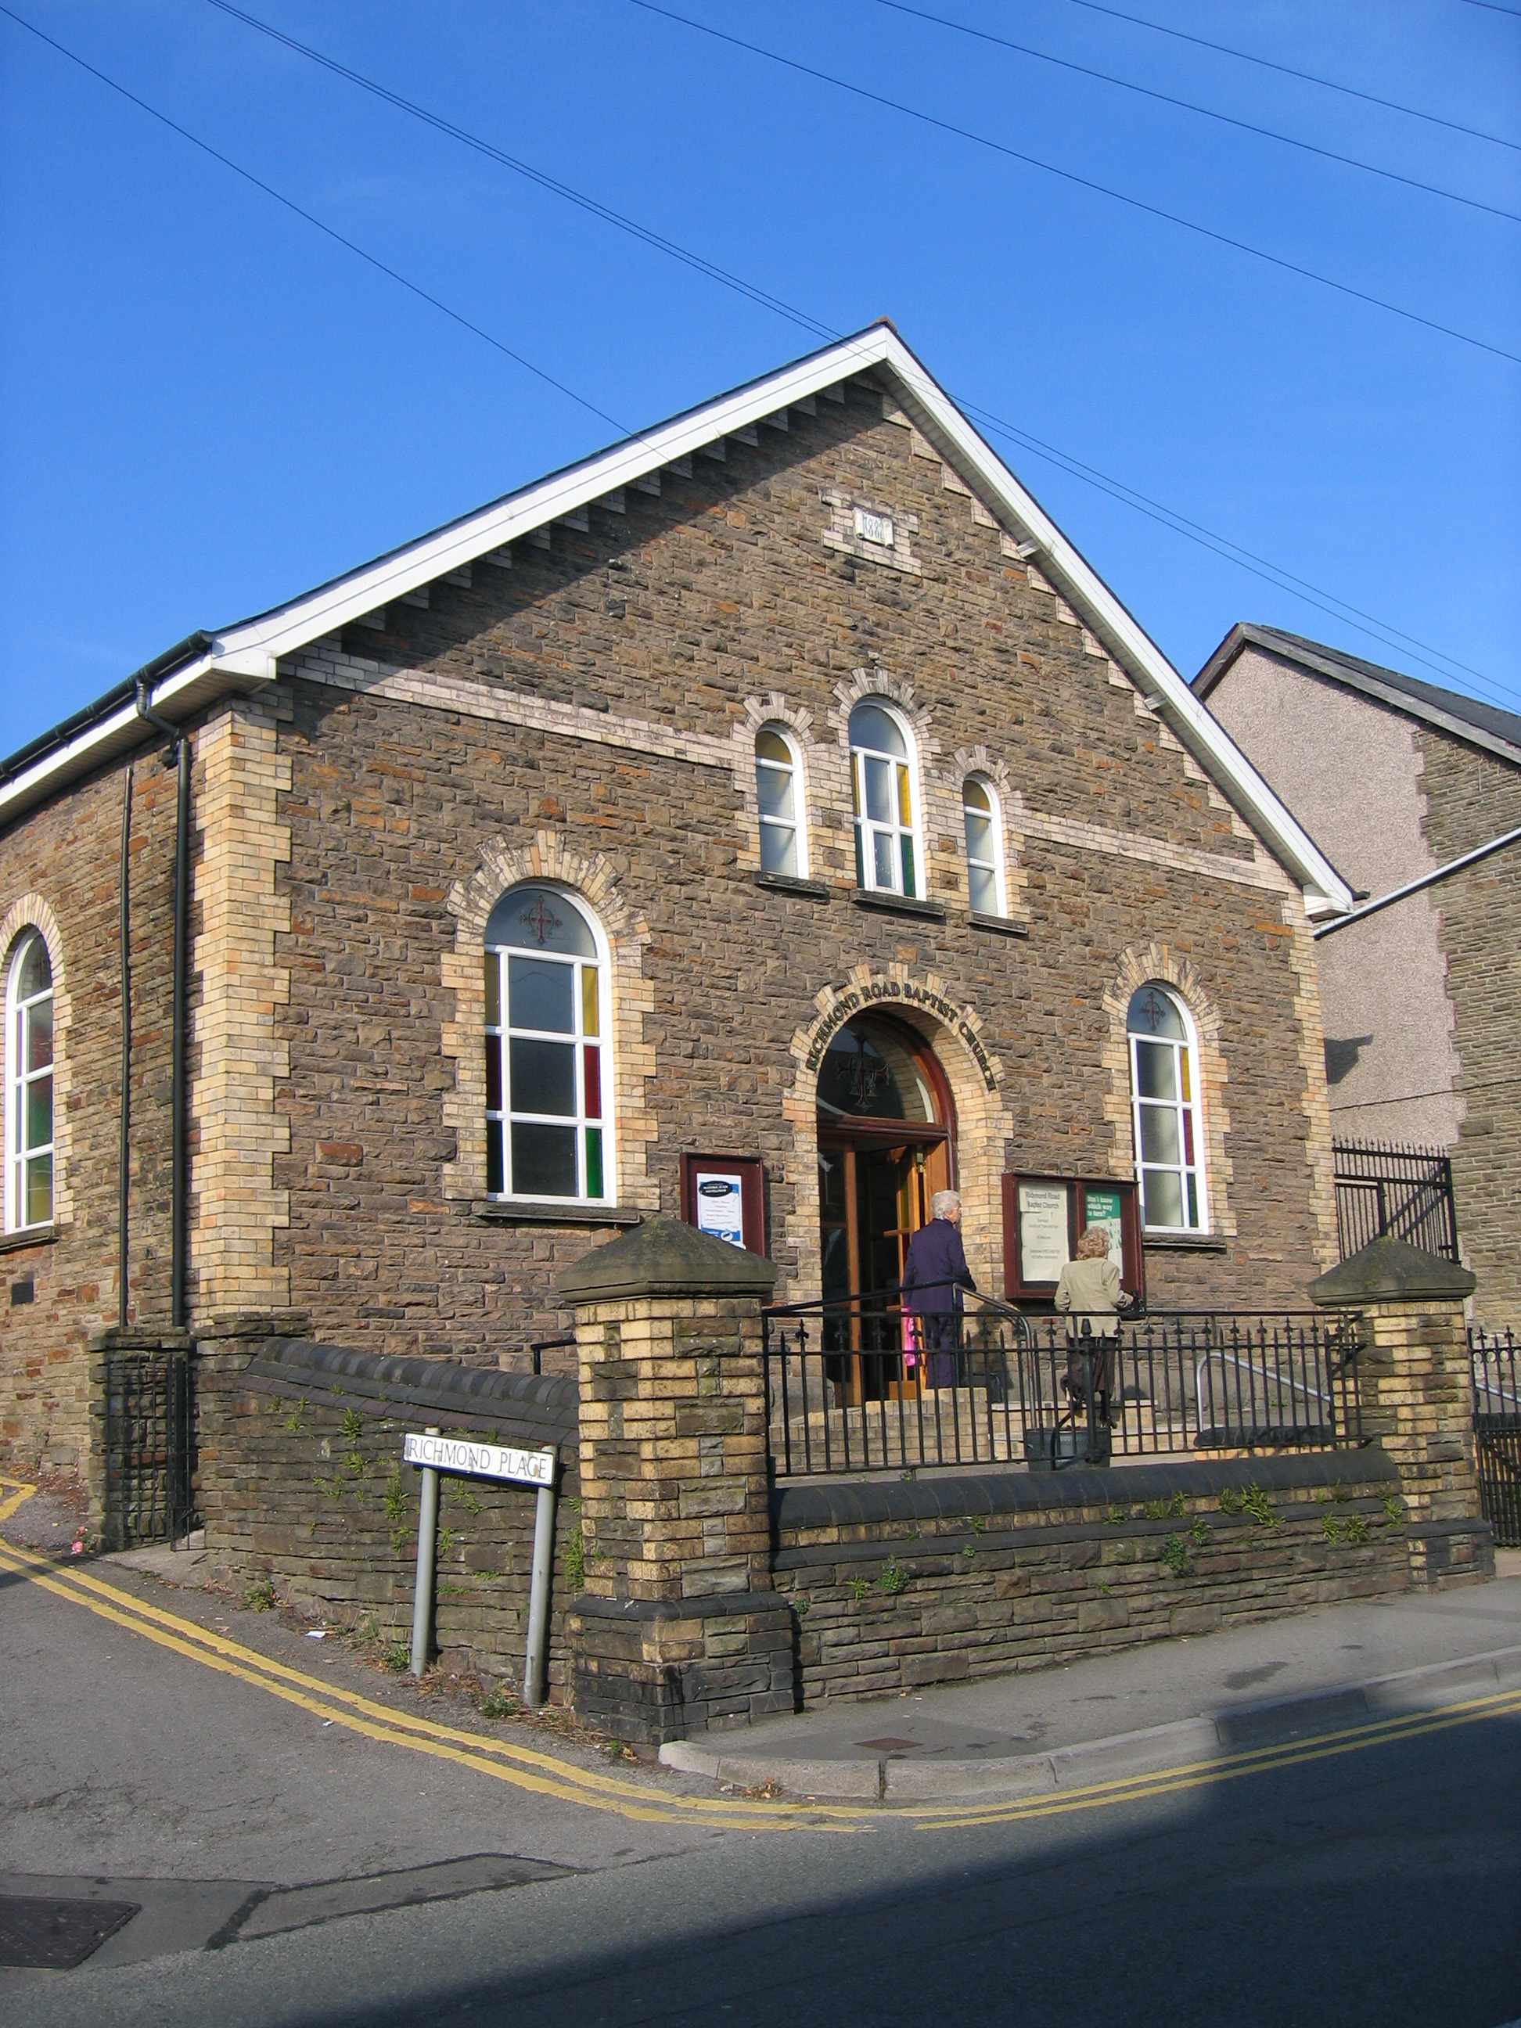Richmond Road Baptist Church
Pontnewydd
www.rr-bc.org.uk/

The Church

General Information
The church was founded in 1875. Currently the church fellowship numbers approximately 90 (75 members and 15 friends). The membership includes all ages, with a greater proportion over the age of 50. The majority of the Church’s fellowship lives within a 5-mile radius of the Church.

Theological Stance: - The membership is open to all who profess repentance towards God, and faith in our Lord Jesus Christ, whose lives bear evidence of their Christian profession, and who have confessed this faith in the Ordinance of Believer's Baptism. Our theology would be best described as ‘mainstream’ with our emphasis on trusting and following Jesus in Christian discipleship. We are committed to ecumenical relations and are active in Cwmbran Churches Together.

Worship & Music: Like all Churches we have been affected by the Covid-19 pandemic. Prior to the imposition of lockdown restrictions we used a mixture of traditional and contemporary styles of worship, regular ‘All-Age’ Family Services and occasional Cafe Church services. The music was provided by the piano (electric) often with drum or guitar accompaniment. We have 3 pianists who play on a rota basis. The hymns & songs were generally sourced from SOF Books 1 to 5 and BPW.
Throughout lockdown each week Sunday morning service and Tuesday evening prayer meetings were held on WhatsApp and some communion services on Zoom. Those who do not have IT access received a printed transcript of the Sunday service either delivered by hand or by Royal Mail.
As restrictions eased we commenced ‘Hybrid Services’: a limited number attending in person, others joining on Zoom and WhatsApp. The music is pre-recorded, some by our pianists and some obtained from online sources. We use a data projector to show the hymns, PowerPoint, Proclaim and DVD presentations on to a wall screen. Since commencing the hybrid services we have welcomed eight people into membership by baptism and transfer.

Outreach & Community: We have a part-time community worker (16 hours a week). There is a Ladies Fellowship and a Men’s Fellowship.
Prior to lockdown our outreach activities were: -
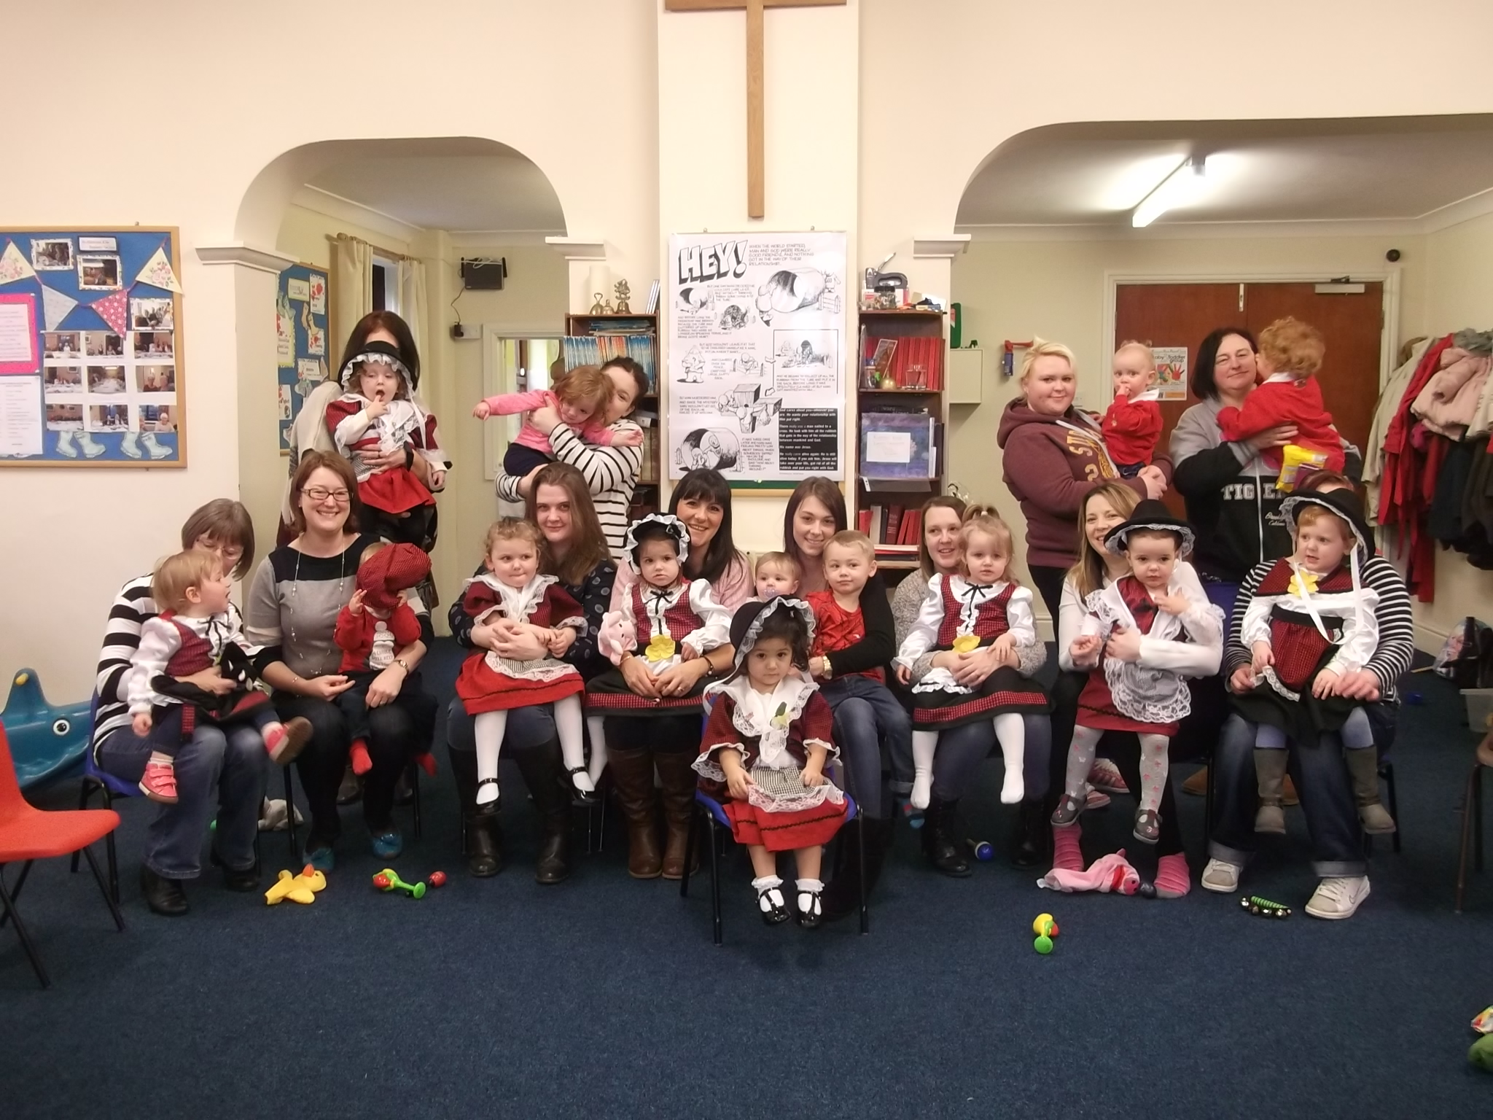Parent & Toddler Group: an informal morning session for parents, babies and children up to 3 years

Pebbles: an afternoon Baby & Toddler Group,
Ground Breakers: an after school club for Primary School Years 1 to 3
A weekly community coffee morning
A monthly community lunch
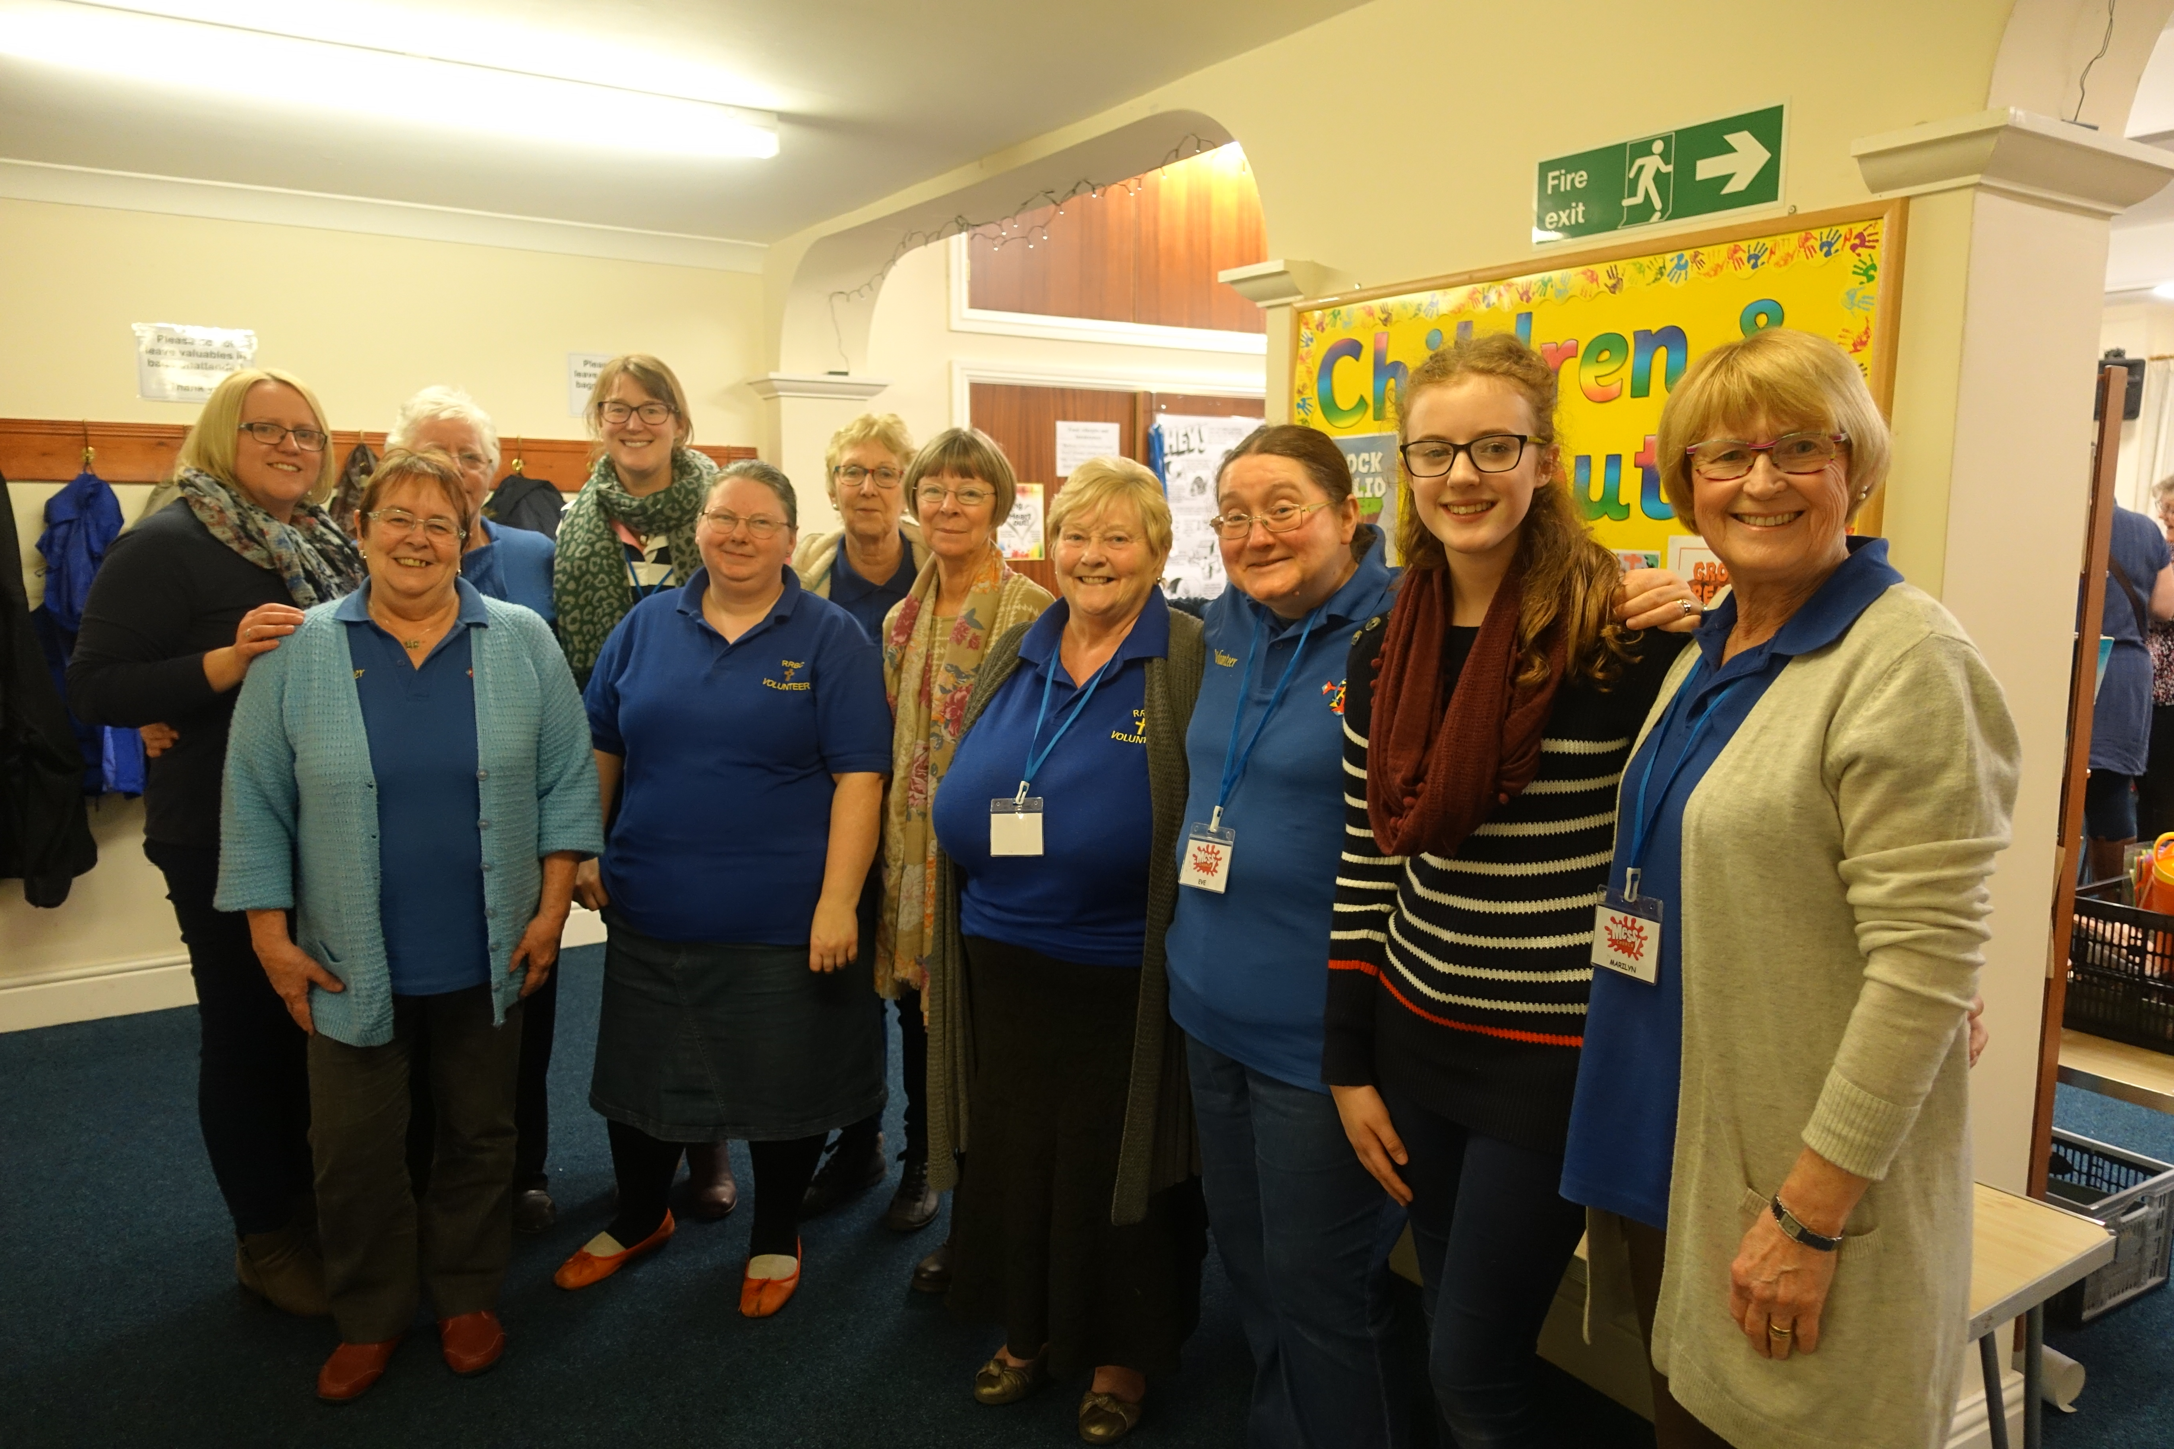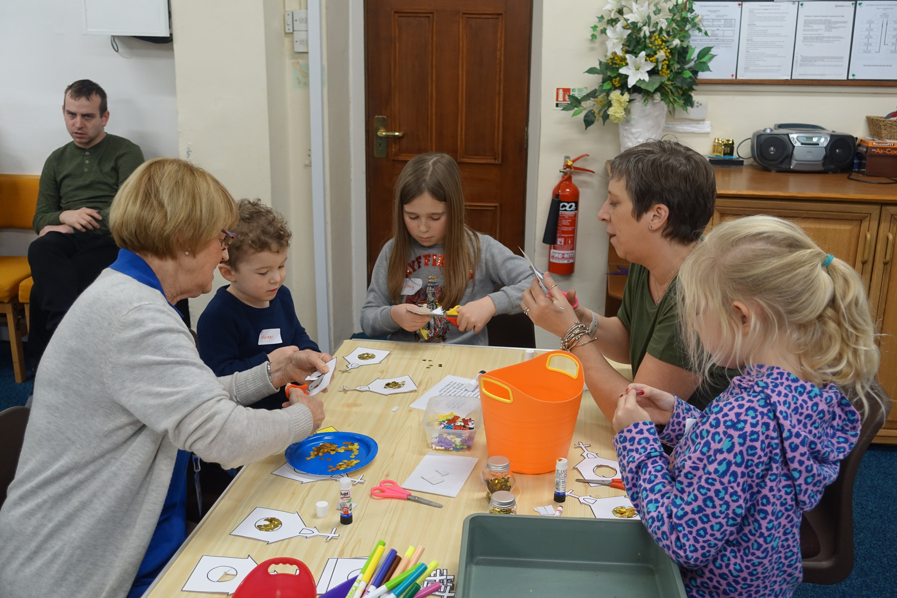A monthly Messy Church

Youth Fellowship: we had a flourishing weekly meeting but regrettably some disruptive youngsters made the situation such that the meetings had to be suspended. Then ‘lockdown’ came and so the future is still under consideration and discussion.
‘Sing your heart out’: an informal singing session for anyone but especially for the lonely and those with health issues.
‘Adopt a Shop’: individuals adopted a shop (within Pontnewydd village) to befriend and pray for. This resulted in the businesses, together with the local primary school, engaging in Christmas and Easter trails.
Local Primary School: links have been forged with the local primary school which involved leading assemblies, ‘Open the Book’ sessions and hosting visits of school classes to the Church.
It is planned to recommence many of these activities as restrictions are eased and when it is safe to do so. We have commenced for a trial period a weekly Renew Wellbeing Cafe replacing the Community Coffee Morning.

Location
The Church is situated in the village of Pontnewydd which was incorporated into the town of Cwmbran, Wales. Cwmbran was a new town established in 1949 to provide new employment opportunities in the south eastern portion of the South Wales Coalfield. Its formation was based around the villages of Old Cwmbran, Pontnewydd, Upper Cwmbran, Croesyceiliog, Llantarnam and Llanyrafon. It has a population of over 48,000.
The town is well served by Primary Schools and has two Secondary Schools, Croesyceiliog School and Cwmbran High School. Coleg Gwent’s Torfaen Learning Zone is situated in Cwmbran and provides 6th form education. There is also a Welsh medium school, Ysgol Gymraeg Cwmbrân.
Cwmbran has a town centre which is a popular shopping destination as it is mostly under cover and has three thousand free car parking spaces. It has many supermarkets and several retail parks.
The Minister:
In seeking a minister we consider our main needs are for: -
A bible teacher with the ability to direct the fellowship spiritually
A pastoral visitor willing to work together with the pastoral team
A person with a commitment to children and youth work
A person willing to have ecumenical contact with nearby churches
A facilitator of the gifts of others
A community minded person seeking to build on the relationships already created within the village community

Practical Matters
The Church is seeking a full-time Minister. One day per week should be regarded as completely free of Church duties. The Minister is entitled to 25 days annual holiday in each full calendar year (to be taken by agreement with the Diaconate) and in addition is entitled to be absent on 6 Sundays without incurring any responsibility or financial commitment for any replacement. Public Holidays are extra to the 25 days.
The Church follows Baptist Union guidelines and the stipend would be linked to the Baptist Union standard stipend; similarly with Housing Allowance.
The Church has a small 3 bedroom house on site which in the past has been used as a manse. It has not been used as such for the past 6 years at least. It could, if needed, be made available.
Sabbatical Leave in accordance with the Scheme operated by the Baptist Union may be taken without loss of stipend. The Church follows the Baptist Union Guidelines for Maternity and other Parental Leave.

